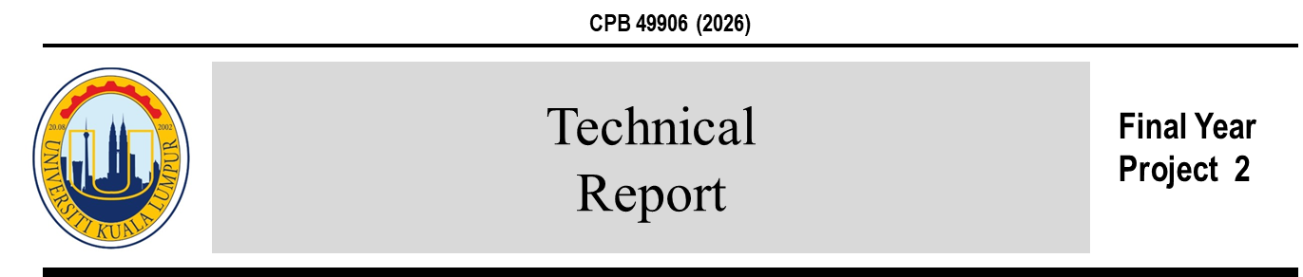
Title of experiment
Student Name*, Co-supervisor Name, Supervisor Name
Chemical Engineering Section, Malaysian Institute of Chemical and Bioengineering Technology, Universiti Kuala Lumpur, 78000 Alor Gajah, Melaka, Malaysia

HIGHLIGHTS

- Highlights

- Highlights

- Highlights

- Highlights

- Highlights

REPORT INFO

Report history:
Submitted 25 June 2025

Keywords:

GRAPHICAL ABSTRACT

ABSTRACT

- Introduction

- Material and Methods

- Results and Discussion

- Figures and tables

- Conclusions

Acknowledgement

References

