IBRAHIM SAAD LEARNING HUB LIBRARY, UNIKL MICET
SURVEY FORM ON LIBRARY INDUCTION PROGRAM

Date: Course:

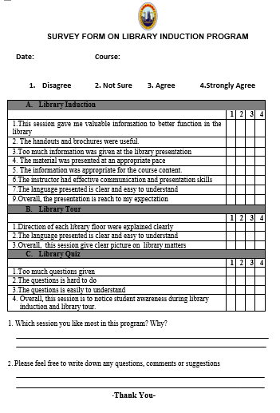
1. Disagree 2. Not Sure 3. Agree 4.Strongly Agree

A. Library Induction
 | 1 | 2 | 3 | 4
1.This session gave me valuable information to better function in the
library
2. The handouts and brochures were useful.
3.Too much information was given at the library presentation
4. The material was presented at an appropriate pace
5. The information was appropriate for the course content.
6.The instructor had effective communication and presentation skills
7.The language presented is clear and easy to understand
9.Overall, the presentation is reach to my expectation
B. Library Tour
 | 1 | 2 | 3 | 4
1.Direction of each library floor were explained clearly
2.The language presented is clear and easy to understand
3.Overall, this session give clear picture on library matters
C. Library Quiz
 | 1 | 2 | 3 | 4
1.Too much questions given
2.The questions is hard to do
3.The questions is easily to understand
4. Overall, this session is to notice student awareness during library
induction and library tour.

1. Which session you like most in this program? Why?

2. Please feel free to write down any questions, comments or suggestions

-Thank You-

